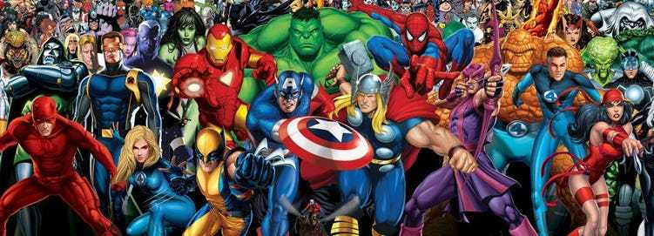
Lesson 2 – Research a Superhero
Choose a superhero you would like to find out about and note down information which you could use to create a fact file about them tomorrow.
Some questions you might want to think about:
What is their name?
What are they known for?
What powers do they have?
How did they get their super powers?
Do they have a weakness?
Who is their ‘alter ego’(disguise)?
Who is their enemy/ies?
What else have you learnt about them that is interesting?

