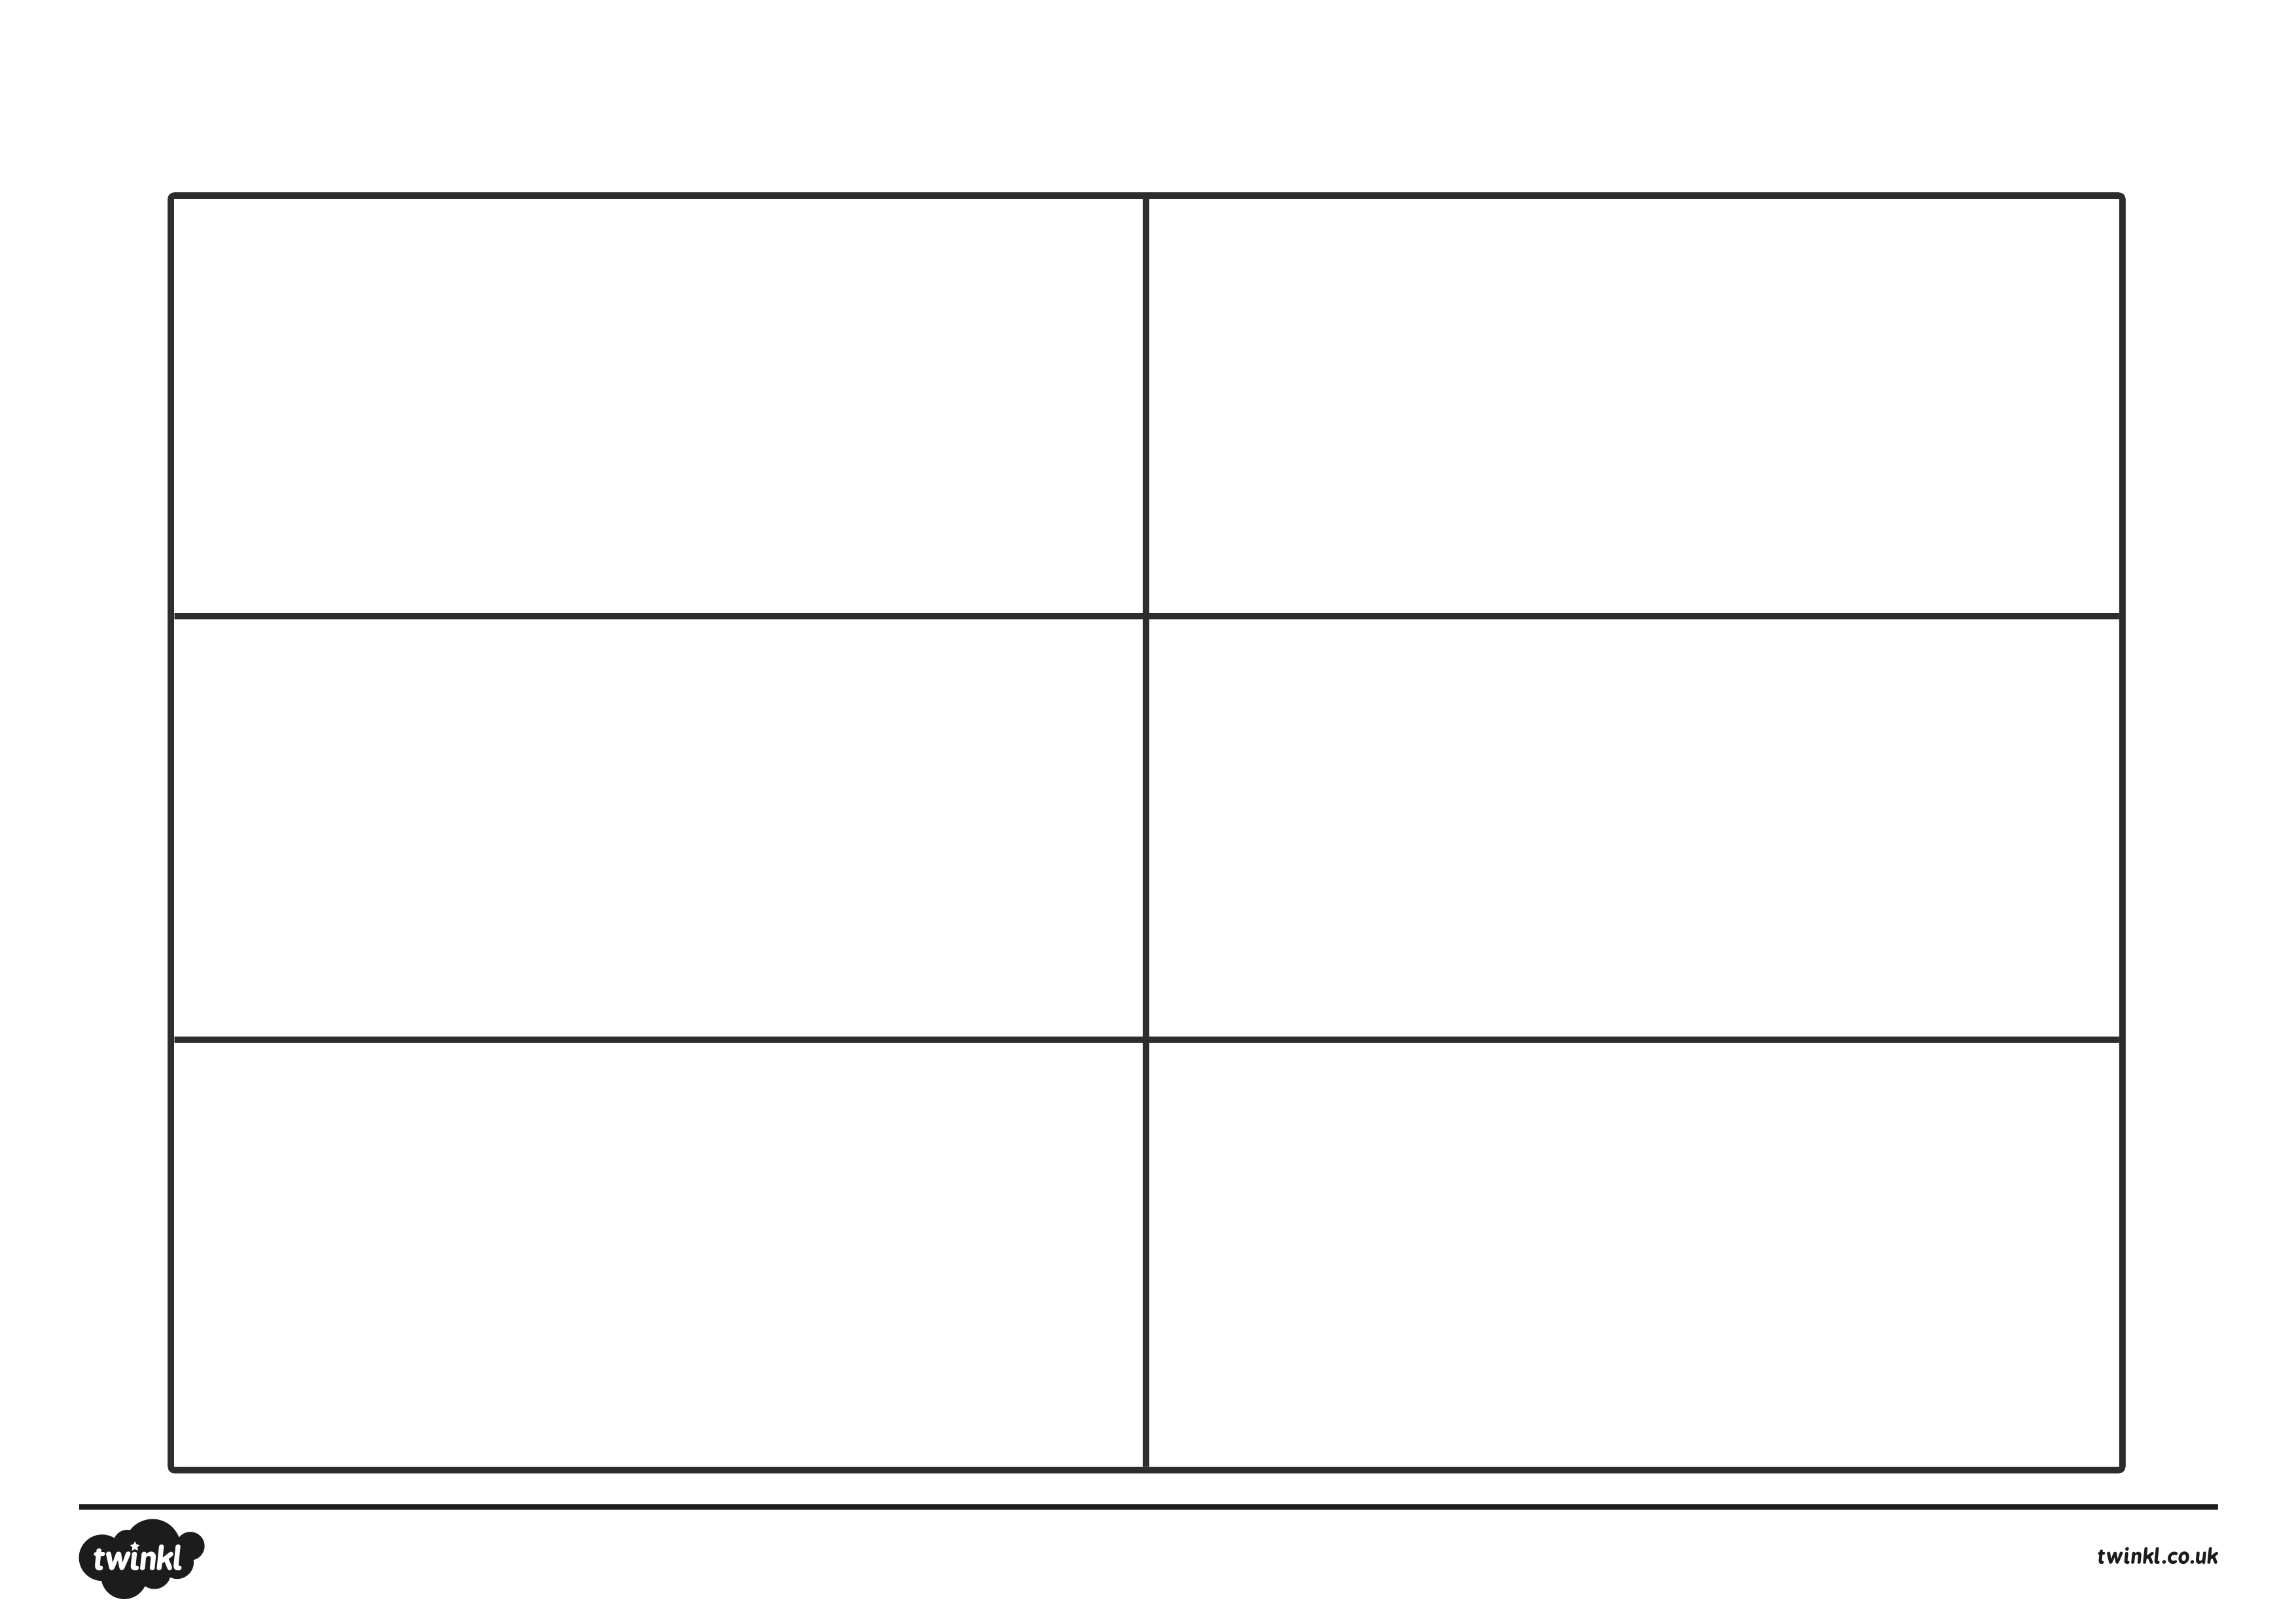
Story Setting Planner
The best stories go into detail to describe the settings. Think about your setting and how you can describe it best.
My setting is:
Smells
Touch
Sounds
Sights
*Challenge - Similes

