

Activity 2 – Gathering ideas

Jot down key phrases and adjectives to describe different aspects of the troll’s character.



Likes/dislikes



Sound/smell

Personality



Physical appearance

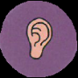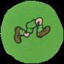

Actions